Agile Group Project COVID-19 Coronavirus Statistics

By

Carell du Plessis

Melissa Nieuwoudt

Yoshiki Tatsumi

Luke Ponga

12/3/2020

ATC New Zealand

Project Proposal

Table of Contents

Introduction 2

Agile methodology 2

Team Members 2

Gantt Chart 2

Pages and mockups 3

Main Page 3

Country list page 3

Map Page 3

Testing 4

Conclusion 4

# Introduction

The aim of this project is the design of an agile / scrum mobile application. We have created an application for Tracking Covid-19 Statistics using Http Client API. Http Client is open-source library that uses Dotnet standard frameworks which allows us to build scalable software by using shared APIs quickly getting access to data. In this application the user can filter through countries by name and retrieve deaths, recovered and active cases of covid-19 with this API were using COVID-19 Coronavirus Statistics API. [https://rapidapi.com/KishCom/api/covid-19-coronavirus-statistics](https://nam10.safelinks.protection.outlook.com/?url=https%3A%2F%2Frapidapi.com%2FKishCom%2Fapi%2Fcovid-19-coronavirus-statistics&data=04%7C01%7C%7Cef03246dd7c04bf3a4ba08d89cb63f6b%7C84df9e7fe9f640afb435aaaaaaaaaaaa%7C1%7C0%7C637431653851241550%7CUnknown%7CTWFpbGZsb3d8eyJWIjoiMC4wLjAwMDAiLCJQIjoiV2luMzIiLCJBTiI6Ik1haWwiLCJXVCI6Mn0%3D%7C1000&sdata=QzxRQ0WCjYbWiiJawBsYBW75Aar37fbCCAIwcCPn7Dw%3D&reserved=0)

Agile methodology

Agile approaches typically advocate a disciplined project management methodology that encourages regular inspection and adaptation which is more effective and encourages teamwork, self-organization and responsibility, a series of best practices designed to facilitate the accelerated delivery of high-quality applications.

Our group used agile / scrum approach in this project. First, we made our task board, we sorted out the team members roles, Team members work on their tasks, and everybody checks in on their progress at the Scrum Meeting. At the end of the Sprint, the team reviews the work accomplished and presents their completed tasks.

# Team Members

All members are assigned a role each member makes their own attempts to successfully complete the project.

|  |  |
| --- | --- |
| **Team Members:** | **Roles:** |
| Carel | Team Leader |
| Melissa | Api Developer & UI |
| Yoshi | Back end Developer (api) |
| Luke | Scrum Master & Tester |

# Gantt Chart

|  |  |  |  |  |  |  |  |  |  |  |  |  |  |  |  |
| --- | --- | --- | --- | --- | --- | --- | --- | --- | --- | --- | --- | --- | --- | --- | --- |
| **Stages** | **Tasks** | **Week 1** | | | **Week 2** | | | | **Week 3** | | | | **Week 4** | | |
| **Planning** | Kick off Meeting |  |  |  | |  |  |  | |  |  |  | |  |  |
| Research and analysis |  |  |  | |  |  |  | |  |  |  | |  |  |
| Project Proposal |  |  |  | |  |  |  | |  |  |  | |  |  |
| **Execution** | UI Design |  |  |  | |  |  |  | |  |  |  | |  |  |
| Development |  |  |  | |  |  |  | |  |  |  | |  |  |
| Testing |  |  |  | |  |  |  | |  |  |  | |  |  |
| **Finial** | Documentation and Report |  |  |  | |  |  |  | |  |  |  | |  |  |

# Pages and mockups

## Main Page

the main page of the application will be shown first. On this page there are three buttons Country List, Map, Exit. When the user clicks on “country list” button users navigate to Country List Page. The “Map” Button navigates to the Map Page. “Exit” Button kills the application.

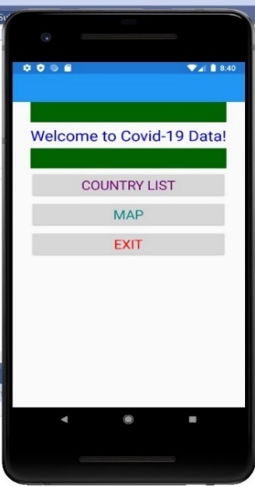

## Country list page

Country list page displays 20 countries each country has 3 rows first row Country Name, second row Deaths, cases, recovered labels and third row shows the data of deaths, cases, and recovered. it retrieves the data for each country with API Tracking Covid-19 Statistics.

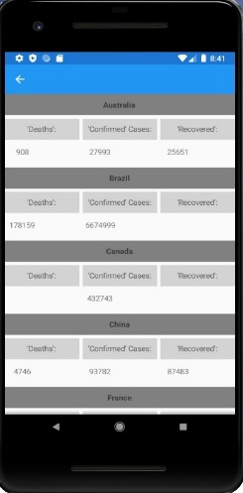

## Map Page

Map Page has an entry box to enter in a country name and a button “Check Covid-19 in This Country” which takes the user to their entered country and displays data off that country using “Tracking Covid-19 Statistics” also has google api to find the country location and move to location.

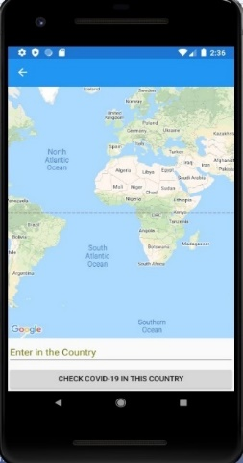

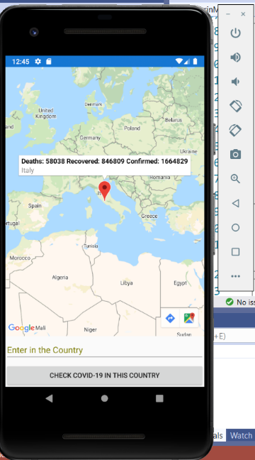

# Testing

|  |  |
| --- | --- |
| **Testing:** | **Review:** |
| **Buttons** | All buttons working as they should. |
| **Pages** | Each page displays everything we wanted |
| **API** | Api is retrieving data |
| **Country entry** | Map api moves me to my entered location |
| **displays data for specified country** | Once the map api locates the user to there entered country they clicked on the red pin and it displays covid-19 data |

.

# Conclusion

In Conclusion this project is based on agile/scrum methodology which was shown to be effective in developing the Xamarin Application Covid-19 Statistics Tracker in a group.